

**Mission 9:**

**Remix**

**Student Workbook**



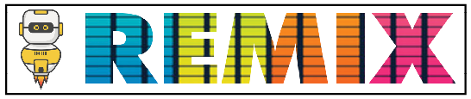

**Make a functional program!**

This assignment will let you be creative and come up with your own program for the   
CodeX to run.

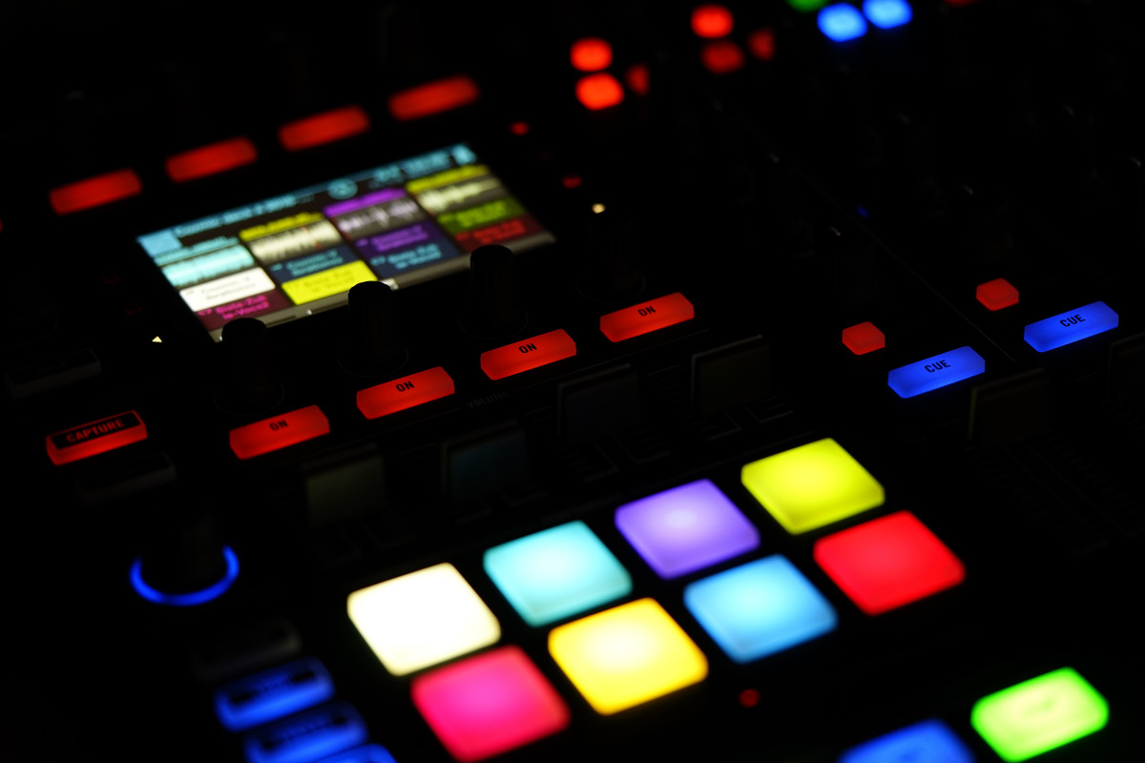

Go to the Mission 9 Remix Log and fill out the Pre-Remix preparation.





**Time for a project remix**

A remix can be:

* A new program created by adding new code to a program you already created
* You can combine parts of two or more programs in a remix
* Use a similar idea in a different way

**Creating a remix will let you:**

* Master the skills and concepts practiced in the mission
* Be creative
* Remember code from earlier programs and missions
* Work with your peers
* Design an original program and write the code all on your own

**Step #1: Review the mission**

* Review your programs from Mission 3 through 9
  + What do the programs do?
  + What skills were used or concepts learned?

**DO THIS:**

* Open your project from Mission 9 -   
   Game Spinner
* Review what the program does
* Review the programming concepts and   
   skills you learned
* Fill out the information in the remix log

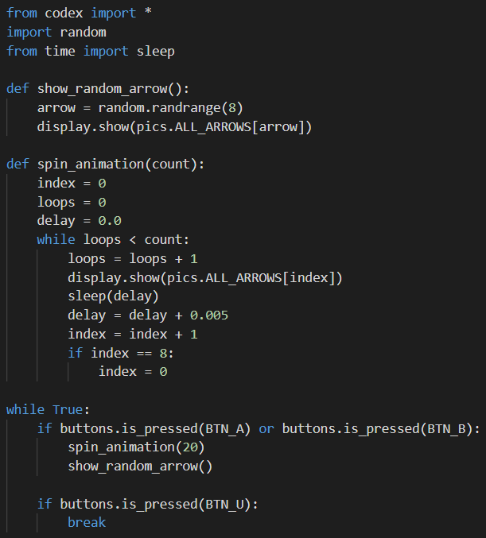

**Step #2: Brainstorm ideas**

* Read through remix suggestions.
  + Six ideas are on the next pages. You can use any of these ideas or come up with your own.
  + You can combine any parts of the suggestions into your own mild, medium, spicy or extra spicy remix.
* Use your creativity to come up with your own idea for a project.
* Decide with your partner what project you will do.



**Mild Remix #1A**

Create a function that will give an introduction and wait to start the game spinner. Then add a button to break out of the infinite loop and end the program with a message.

[Video of Remix #1A](https://youtu.be/tKLRUn2pVBw)



**Mild Remix #1B**

Add a beep for each arrow spin.

[Video of Remix #1B](https://youtu.be/x3odEytcOnM)



**Mild Remix #1C**

Make the animation spin counterclockwise instead of clockwise.

[Video of Remix #1C](https://youtu.be/vh7AcNfSI8A)



**Medium Remix #2A**

Use BTN_A for spinning clockwise and BTN_B for spinning counterclockwise.

[Video of Remix #2A](https://youtu.be/4f2T1JyGpeY)



**Medium Remix #2B**

Many games use colors, numbers or specific images on the wheel. Show a random color (or large number) on the screen. Instead of ending with a random arrow, get a random number for count and whatever is showing at the end is the selection. (Only one function is needed.)

[Video of Remix #2B](https://youtu.be/wTdMm5-O9So)



**Spicy Remix #3A**

Use both Button A and Button B for two different things. For example, use button A for the arrow spin and button B for the dice roll. Or button A for arrow spin and button B for colors.

[Video of Remix #3A](https://youtu.be/xYnkvNcX-Ag)



**Spicy Remix #3B**

Create another list and use a different beep for each arrow.

[Video of Remix #3B](https://youtu.be/S_SYhuhtwwg)



**Spicy Remix #3C**

Create a 2-player game. Each player presses their own button. Use the dice roll or assign points to the arrows or colors. The first player to a point value wins.

[Video of Remix #3C](https://youtu.be/sjWmjIUMzyY)



**Extra Spicy Remix #4A**

Many games use two dice. Create a program that rolls two dice at the same time.

[Video of Remix #4A](https://youtu.be/5Oo38Y2aRTM)



**Extra Spicy Remix #4B**

Create a color-match game. Display two rectangles, each with a random color. How long does it take to get matching colors?

[Video of Remix #4B](https://youtu.be/Lux93_Ai-pQ)

**Step #2: Brainstorm ideas**

**DO THIS:**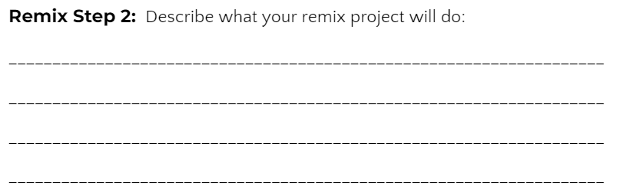

* Decide with your partner what project you will do
* Fill out the information in the Mission 9 Remix Log for **Step #2**

**Step #3: Make a plan**

Now that you have an idea for your remix, you need a plan.

* What variables will you need?
* What functions will you create for the program?
* What lists will you use, and what information will they store?
* What buttons will you program, and what will each button do?

**DO THIS:**

* Fill out the information in the Mission 9 Remix   
   Log for **Step #3**

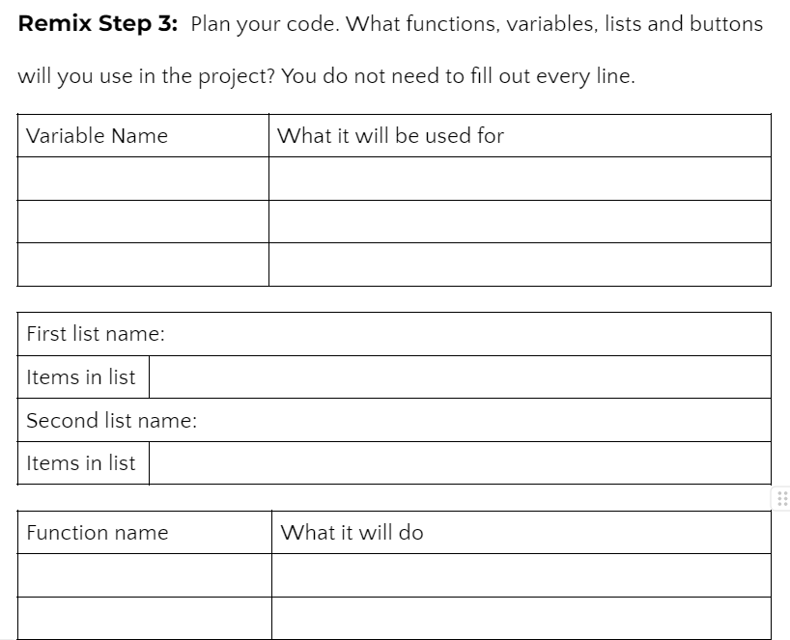

**Step #4: Code your project**

* **IMPORTANT:** In CodeSpace, go to the sandbox: 
* You can leave any program open, including **Game Spinner**, and use it as a guide



**DO THIS:**

* Start with a new file and give it a descriptive   
   name (**Remix9**)
* Import your modules
* Create your lists
* Define your variables
* Write your code, testing frequently

**Reminders!**

* Don’t try to write all the code at one time
* Think about the steps –
  + Just get one thing to work, and then move on
  + Step by step!
* Mistakes happen, so find them early
* Type just a few lines of code and then run the program
* If there is an error, fix it before continuing
* Use the debugger and your other programs for help

**Step #5: Documentation**

You should always make your code readable and easy to follow.

**DO THIS:**

* + - * Add blank lines where needed to divide sections of code
      * Add a comment at the top with your name and the name of the program
      * Add a few more comments to sections of your code that explain what they do

**Step #5: Get feedback**

Getting feedback and reflecting on your code can help you make the program even better.

**DO THIS:**

* Show your code to another student
* Have him/her fill out the feedback form on your   
  Mission 9 Remix Log
* Get feedback from someone else (or yourself)
* Have him/her fill out the feedback form on your   
  Mission 9 Remix Log

**Modify your code to make your project even better**

**Congratulations!**

Now you have your own remix!   
Great job! Share your project with   
your friends.

By completing this remix you have:

* learned more about programming
* used skills and concepts from the missions
* been thinking!
* and problem solving
* and much more!
* 

**DO THIS:**

* Run projects from other   
   students
* Complete the Mission 9 Remix Log
* Don’t forget to clear your CodeX by   
   running your **Clear** program